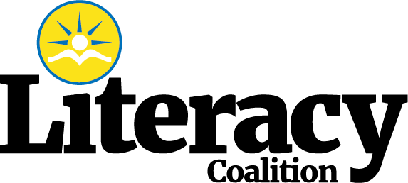
Key Components of the
Dyslexia and Early Literacy Screening and Intervention Pilot Expansion:
PDE is Accepting: 15 new LEAs with varying numbers of buildings and district demographics
Deadline to Apply: October 31, 2019

Districts Must:
- Central office leader as well as building-based buy-in
- Commitment to training, ongoing TA, assessment, data collection,
- Onsite and virtual visits to the pilot district for training, implementation review,
- Training for all K-2 in bldg. with special ed, title I, ESL and speech/language
- Staggered start within the district with bldg. Implementation

Prior to Selection:
- Onsite visitation prior to selection to assess district capacity and gauge the commitment of administrators and teachers.

Once Selected:
- After the selection process, a joint kick-off meeting to review parameters and schedule training dates.
- Initial meeting with the pilot district prior to the kick-off meeting to review parameters of pilot training for some consistency in communications
- Supplement pilots with contracted consultants and other vendors as needed to support sites

Training:
o Classroom-based training in evidenced-based foundational reading instruction and resources.
o Intervention training and resources:
Structured Literacy (e.g. Orton-Gillingham Approach, Lindamood-Bell, Project Read, Sonday, Association Method, Language!, Alphabetics Phonics, Lexia-Herman Method, Slingerland, Spalding, Sounds in Syllables, Starting Over, or Wilson

Intervention:
o Students selected for intervention based on two-tiered screening
o Districts must adhere to the selection criteria established for the pilot expansion
o Structured Literacy Intervention beginning in Kindergarten
o Intervention groups of no more than 3 students
o Frequency and duration of intervention TBD
o Documentation of intervention type and minutes

Data Collection:
o DIBELS 3x’s year
o Additional Screening Measures as necessary (TBD)

Lead Teachers and Administrative Leaders at Each Site:
o Specific sessions among sites to provide support and share resources for success

End of Year Meeting: review success and plan for next year including sustaining components with internal coaching

Stipend for Districts to offset costs related to travel, meeting participation, data collection, materials, etc. (40,000 /year for 2 years).

Deadline to Apply: October 31, 2019

Questions: Contact Monica McHale-Small at: monica.mchale.small@gmail.com

Click here for the Application to Apply

The Literacy Coalition is a 501c3 Non Profit that believes learning to read
should be a right and an opportunity provided to all children.

